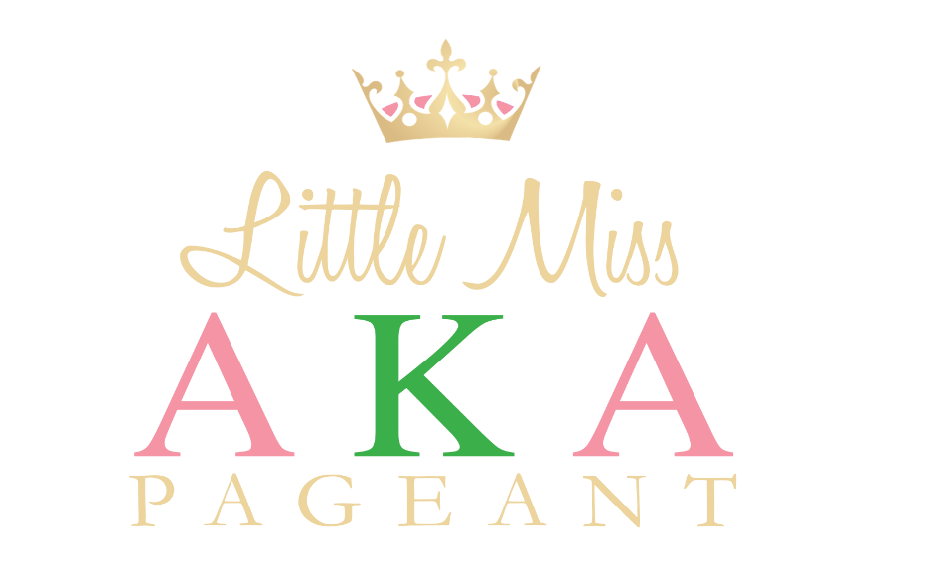

Glitz and Pearls on Pretty Girls

Alpha Kappa Alpha Sorority, Incorporated
Phi Lambda Omega Chapter

and

Pearls of Service Foundation, Incorporated

General Information

Little Miss AKA 2019 Contestant Requirements
- School Age girls
- Age categories: 5-7, 8-10, and 11-12
- Birthdates for above age categories by November 2019
- Fully completed Little Miss AKA Application and Headshot photo
- $50 Non-Refundable Application Fee
- Application, photo and $50 Non-Refundable Application Fee to be received on or before September 7, 2019
- All checks payable to: Pearls of Service Foundation, Inc. PO Box 172007, Memphis, TN 38187
Little Miss AKA Contestant Requirements cont’d

- $500 minimum fundraising goal per contestant in ads, donation, and/or ticket sales. All monies due November 6, 2019.
- Open-mind, positive attitude, and friendly behavior
- Contestant parents/guardians ensure timely drop-off and pick-up of contestants for all meetings, workshops, and rehearsals.

Mandatory Informational Meeting: Saturday, September 7, 2019, 10:00 a.m. – 12 p.m. at Greater Memphis Pentecostal Assembly 8941 E. Shelby Drive, 38125. Contestant parents/guardians will receive a calendar of scheduled meetings, workshops, and rehearsals. Information regarding judging criteria, winners, and awards will be discussed. In addition, we will discuss outfits needed for the Opening Scene – Glitz & Pearls, 2nd scene – Future Occupation, and 3rd scene – Dressy/Formal.

For any questions related to the Little Miss AKA Pageant 2019 Application process, please feel free to contact:

Dr. Princess Cry Parker
2nd Vice President
Alpha Kappa Alpha Sorority, Inc.
Phi Lambda Omega Chapter
(901) 238-1566
Akaprincess1993@yahoo.com

Mrs. Wendy Kirkendoll
Chairman - Little Miss AKA Pageant 2019
Alpha Kappa Alpha, Sorority, Inc.
Phi Lambda Omega Chapter
(901) 604-8844
wekirkendoll@gmail.com

Instructions:

- Parent/Guardian, please complete the application and sign giving permission for your child to participate in the Little Miss AKA Pageant. By signing, you also acknowledge that you have read and agree to all terms and requirements of the Little Miss AKA Pageant.
Little Miss AKA 2019 Pageant Application

(Please print neatly):
Contestant Full Name______________________________________________
Address: ________________________________________________________
City _____________________ State ______________ Zip _______________
Birthday: ___/___/____
School: ____________________________________ Grade: ______________

Parent/Guardian Information:

Mother/Guardian Full Name: ________________________________________
Address: ___________________________________________________
City__________________ State ________________ Zip __________________
Home #: ____________ Cell#:______________Email: ___________________

Father/Guardian Full Name: ________________________________________
Address: ________________________________________________________
City___________________ State ________________ Zip _________________
Home#:_____________ Cell#:_____________ Email: ____________________

Parent/Guardian Signature:

I authorize my daughter ______________________________________, to participate in the Little Miss AKA Pageant sponsored by Alpha Kappa Alpha Sorority, Incorporated - Phi Lambda Omega chapter and Pearls of Service Foundation, Incorporated. With my permission, I will support her active participation in all activities planned as part of the Little Miss AKA Pageant and will meet all financial obligations as intended, but not limited to, the $50 pageant fee and the fundraising goal of $500 minimum.

Signed: ___________________________________ Date: ________________
(Parent/Guardian Signature)

Little Miss AKA 2019 Pageant Application

Contestant Full Name: _____________________________________________

Contestant Biography - Please complete the following information:

Favorite Color: _____________________________________________________
Favorite Food: _____________________________________________________
Favorite Television show: ____________________________________________
Favorite Subject in school: ___________________________________________
Favorite Teacher: ___________________ Why? __________________________
____________________________________________________________________________________________________________________________________

Best Vacation Ever: _________________________________________________
____________________________________________________________________________________________________________________________________

Honors, Awards, Achievements: ________________________________________
____________________________________________________________________________________________________________________________________

Community Service/Church Activities: ___________________________________
____________________________________________________________________________________________________________________________________

Hobbies, Special Interests, Talents: __________________________________
____________________________________________________________________________________________________________________________________

What do you want to do as an adult? _____________________________________
______________________________________________________________________________________________________________________________________________________________________________________________________

Who do you look up to and why? (Role model): ___________________________
______________________________________________________________________________________________________________________________________________________________________________________________________

How did you hear about this pageant? (Circle all that apply)
- Member of Phi Lambda Omega chapter of Alpha Kappa Alpha Sorority, Inc.
- Phi Lambda Omega chapter website
- Pearls of Service Foundation, Inc. TN website
- Facebook/Twitter/Instagram
- Other (please explain) __________________________________________

PLEASE DO NOT WRITE BELOW THIS LINE

For Internal Use Only

Date Rec’d ___________ Participant # ________________ Pageant Fee Rec’d. Yes. No

